Send Youth

WEEKEND AWAY
Send Youth
Youth Weekend | Runways End, Farnborough, GU11 2RE |
9 - 11 February 2024
Our youth group are going away for the weekend! It will be jam-packed with fun activities, challenges, games and chill time.
Runways End Activity Centre comes equipped with lots of great activities which we’ll make use of.
We’ve also invited some friends from St John’s Church, Woking to join us.
Central to the Weekend is the chance to hear from God through his word. Jonathon Burrows, the Youth Minister at Christ Church Cockfosters (in north London) will come to help us dig into what the Bible says about Sacrifice. When he’s not studying, leading the youth team at church, supporting parents, or reaching out to young people with the good news of Jesus, he has a quiet life (just kidding!) at home with his wife Sarah and their 4 children, Rosie, Zac, Bella and Hattie.
The cost of the weekend is £70 per person, which covers accommodation, food and activities for the weekend. Please arrange your own transport to and from the venue. Arrival time at Runways End is 6:30pm on the Friday. The departure time on Sunday will be around 2pm (TBC).

Booking Form
Weekend Away, 9-11 February 2024
Please return this form to Kurt by Friday, 8th December, and pay the £20 deposit.
The total cost of the weekend is £70.00. The balance payment of £50.00 is due by Sunday 21st January 2024. Please speak to Kurt if you will struggle to cover this cost – we don’t want anyone to miss out due to finances.
Further details of the weekend including a kit list will be provided in a letter to parents in January. A medical consent form (required to participate in activities run by Runways End staff) will also be issued immediately prior to the weekend.

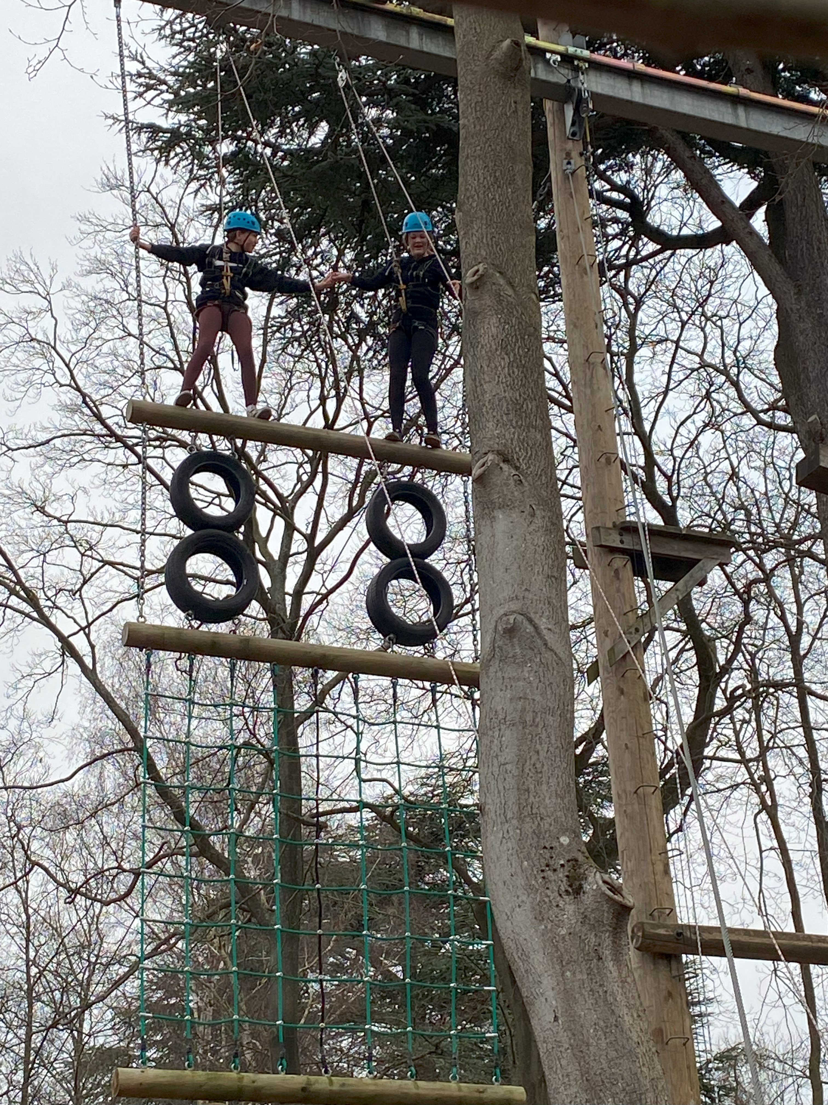
TO BE COMPLETED BY PARENT/GUARDIAN:
One form per child please
Name:
School Year:
Dietary Requirements / allergies, and additional needs:

I enclose a non-returnable £20 deposit (or full amount)
c By online payment (reference payment with child’s full name so we can identify it).
Sort Code: 40-47-08 (HSBC)
Account Number: 82579383
Account Name: Send Evangelical Church

Signature of Parent/Guardian

TO BE COMPLETED BY YOUNG PERSON:
I understand that there will be Christian teaching whilst we are away, and I agree to co-operate with leaders at all times.

Signature:

